Assessment Task for Reading
Topic: Moving to Hong Kong
This assessment task focuses on developing senior secondary students’ reading skills.

This set of materials contains the following:

- The reading texts
- A set of questions
- Suggested answers

1  5 | I can’t believe we only arrived yesterday. It feels like we’ve been here for a week already. Today we’ve had an ambitious day of appointments and errands. After breakfast in the hotel, we went on the MTR (subway) to a real estate agent who took us to see some possible rental units. They are quite close to where our new school is. The apartments are really small compared to our house at home, but most blocks have a swimming pool and a gym. I like the second one we looked at as there are 4 bedrooms and we can all have our own room. Mum thinks it’s a bit far from the school, though.
10  15  20 | After looking round the apartments, we went to visit our new school. It seems quite nice, but it has lots of stairs and the corridors are outside not in the middle of the classrooms! We also headed to Tak Wing Fabrics after we had lunch to get our new uniforms. Tak Wing provides uniforms for many of the international schools in the city. So both of my sisters and I have been kitted out with two sets of red polo shirts and navy blue skirts, plus a zip-up jacket and a school baseball cap (called a sunhat here) which we wear most days, and one set of PE uniform with red t-shirt and red shorts for days when we have PE, and one set of uniform for the house (just like Gryffindor in Harry Potter!) to be worn on house meeting days. We are in the Purple House, so we have a purple shirt (the others will wear yellow, green, red or blue shirts on House meeting days).
25 | We had a minor situation when my little sister learned that the uniform included a skort for the girls, but the owner then clarified that “some” girls wear skirts right through the elementary years rather than just in secondary. She was much happier with the skirts, but we did buy one skort in case the whole grade is wearing skorts and there is a massive panic on the first day.
30 | We then rode back to the hotel and met up with Dad who had to work this morning. We took a brief rest and then set out to get dinner early as we are still not on Hong Kong time. We travelled to my mom’s favorite mall in town for its big book store and Pizza Hut. The Pizza Hut had table service and delicious pizzas with interesting flavors and unexpected combinations. A number of the pizzas had Thousand Island dressing instead of tomato sauce, but I wasn’t brave enough to try them this time. Mum said we had to be sure to request no ice for our drinks as you never know where it was coming from.
35 | By 6:00 my little sister was exhausted and being a real pain in the neck. Having been awake since 10 pm the night before, her body was shutting down. And we all were wiped out really. Time to get some R and R and recover for tomorrow when we go to the Immigration Department to get our Hong Kong identity cards.
Alice Roley’s Hong Kong Odyssey:
Day 2 – Home & school
Recent posts:

We’ve arrived!
2 comments

Sally posted on 14 January

Hi Sweetie
It’s good to hear how you’re getting on. I want to see pictures! I think you should definitely try the Thousand Island pizzas next time. You need to throw yourself into the whole Hong Kong experience and try new things, remember! OK perhaps comfort food is best when you’re jet-lagged and tired. Maybe next time!
Love to everyone, Sally.

Jenna posted on 15 January

Wow, it all sounds fantastic. You’re so lucky! I bet you all could sleep for a week! I hope you get your own room. When do you start school? Let me know what it’s like. Hope the teachers are cool. I can’t wait to see pictures of you in your uniform. And let me know about any cute guys there!!! Keep up the fabulous posts – I love to read about the food . . .

Post a comment

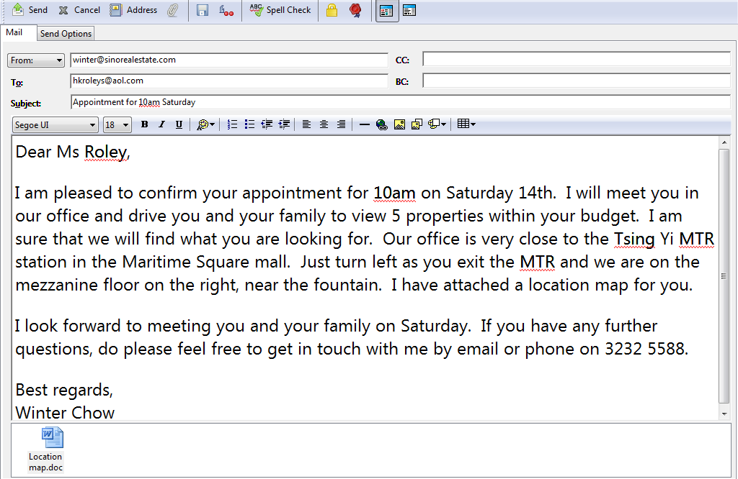

Letting information:

1900 sq ft apartment – furnished

$43,000 / month

Full description:

Scenic Court - 3-bedroom apartment. The property features a large living and dining room with floor to ceiling windows and access on to a large balcony. The kitchen is modern and fully fitted. The master bedroom has a balcony and ensuite bathroom and there are two other bedrooms and two further separate bathrooms. Scenic Court is minutes from Tsing Yi MTR and Tsing Yi transportation hub, making it very easy to commute to the city in no time. Membership of its clubhouse is available to residents at a cost of $3,000 / month. Clubhouse facilities include 2 restaurants, a swimming pool, a gym and tennis courts. Call today to arrange a viewing.

Letting information:

2034 sq ft penthouse apartment – furnished

$51, 000 / month inclusive

Full description

La Vista – 3-bedroom apartment and roof. A beautiful penthouse in this recently opened development. It enjoys stunning views of Hong Kong. Beautifully furnished throughout, the property consists of 3 bedrooms, a large living / dining room, a kitchen, 3 bathrooms, storage space and a huge roof garden featuring a jacuzzi. Parking space available. Residents enjoy full access to La Vista’s gym and leisure facilities, including a free-form swimming pool. Must be viewed.

END OF READING TEXTS

Questions
Read the texts on pages 2 -4 and answer questions 1-14. Blacken the circle when appropriate.

- Use Alice’s blog to complete her schedule for 14 January. (5 marks)

9.00am | MTR to Tsing Yi
10.00am
11.30am
12.00pm | Lunch at Chinese cafe
2.00pm
3.30pm | Back to hotel for a rest
4.30pm
6.00pm

- What does Alice say is like Gryffindor? (1 mark)

A. | the school uniform
B. | the school house
C. | purple house |  | A | B | C | D
D. | the school

- How many houses are there at the girls’ school? What are they? (2 marks)
_______________________________________________________
_______________________________________________________
_______________________________________________________

- List what Alice and her little sister usually wear to school. (4 marks)
______________________________________________________
______________________________________________________
______________________________________________________
______________________________________________________

- How many members are there in Alice’s family? (1 mark)
______________________________________________________

- What does “it” in line 33 refer to? (1 mark)
______________________________________________________

- In the first comment, why does Sally tell Alice to try the Thousand Island pizza?
(1 mark)
_______________________________________________________
_______________________________________________________
- What does Sal mean by comfort food? (1 mark)
A. | Thousand Island dressing pizza
B. | new food
C. | familiar food |  | A | B | C | D
D. | pizza with tomato sauce

- What is Jenna interested in seeing more of in Alice’s blog? (4 marks)
_____________________________________________________
_____________________________________________________

10. Give one reason why everyone in Alice’s family is so tired. (1 mark)
_____________________________________________________

11. a. Which of the people who posted a comment on Alice’s blog (1 mark)
do you think is her Aunt?
_____________________________________________________

b. What do you think Alice’s relationship with the other poster is? (1 mark)
_____________________________________________________

12. Enter the real estate agent’s contact details in Alice’s mother’s phone. (4 marks)

Surname: _______________________________

Given name: _____________________________

Tel: ____________________________________

Email: ___________________________________

________________________________________

13. In the real estate notice for La Vista, what does the word “penthouse” mean? (1 mark)
____________________________________________________
14. Help Alice’s parents compare the two flats by completing the table. (13 marks)

 | Scenic Court | La Vista
Size
Private space outdoors

Clubhouse Facilities | 1.  2.  3.  4. | 1.  2.
Total rent

END OF QUESTIONS

(Copyrights reserved by Education Bureau)

SUGGESTED ANSWERS

1. | 10.00am – meet estate agent / see rental units / look round apartments (blog lines 3-5/9) (1 mark)  11.30am – visit school (blog line 9) (1 mark)  2.00pm – buy school uniforms (at Tak Wing Fabrics (blog lines 11-12) (1 mark)  4.30pm – go out for dinner (at Pizza Hut) (blog lines 27-8) (1 mark)  6.00pm – go back to hotel (to sleep) (blog lines 34-36) (1 mark)
2. | b. the school house (blog line 18) (1 mark)
3. | 5 (blog lines 18-19) (1 mark)  Yellow, Green, Purple, Blue, Red (blog lines 18-19) (1 mark)
4. | a red polo shirt (blog line 14) (1 mark)  a navy blue skirt (blog line 14) (1 mark)  a zip-up jacket (blog line 14) (1 mark)  a sunhat or baseball cap (blog line 15) (1 mark)
5. | 5 (blog lines 7-8, 13, 26) (1 mark)
6. | ice (blog line 33) (1 mark)
7. | to try new things / experience new things (comment 1 lines 3-4) (1 mark)
8. | c. familiar food (comment 1 lines 3-4) (1 mark)
9. | what the school is like; pictures of the uniform; cute guys; food (blog comment 2 lines 2-4) (1 mark each)
10. | They are jet-lagged. (comment 1 line 4) // They’ve been awake since 10pm the night before (blog line 35) // They only arrived yesterday (blog line 1) (1 mark)
11. | a. Sally (1 mark)  b. friend (1 mark)
12. | Surname: Chow (1 mark)  Given name: Winter (1 mark)  Tel: 3232 5588 (1 mark)  Email: winter@sinorealestate.com (Email) (1 mark)
13. | top-floor flat (1 mark)
14. | 1900 sq ft (1 mark)  (2) balconies (1 mark)  (2) restaurants (1 mark)  pool (1 mark)  gym (1 mark)  tennis courts (1 mark)  minutes from / near Tsing Yi MTR (1 mark)  $43,000 per month (1 mark) | 2034 sq ft (1 mark)  roof / roof garden (1 mark)  pool (1 mark)  gym (1 mark)  $51,000 per month (1 mark)

ENG OF SUGGESTED ANSWERS

(Copyrights reserved by Education Bureau)

